**Assignment:** Intelligence Databases-Assignments

**By:** 220019977

-- Prerequisite table

CREATE TABLE PATIENT (

ID NUMBER PRIMARY KEY,

NAME VARCHAR2(100) NOT NULL

);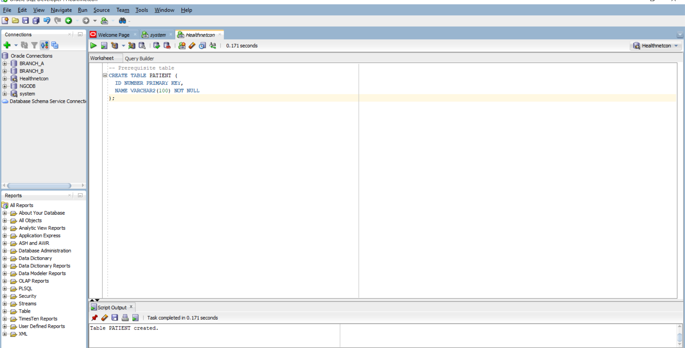

-- Corrected PATIENT_MED table

CREATE TABLE PATIENT_MED (

PATIENT_MED_ID NUMBER PRIMARY KEY, -- unique id

PATIENT_ID NUMBER NOT NULL REFERENCES PATIENT(ID), -- must reference an existing patient

MED_NAME VARCHAR2(80) NOT NULL, -- mandatory field

DOSE_MG NUMBER(6,2) CHECK (DOSE_MG >= 0), -- non-negative dose

START_DT DATE,

END_DT DATE,

CONSTRAINT CK_RX_DATES CHECK (

START_DT IS NULL OR END_DT IS NULL OR START_DT <= END_DT

) -- sensible date logic

);

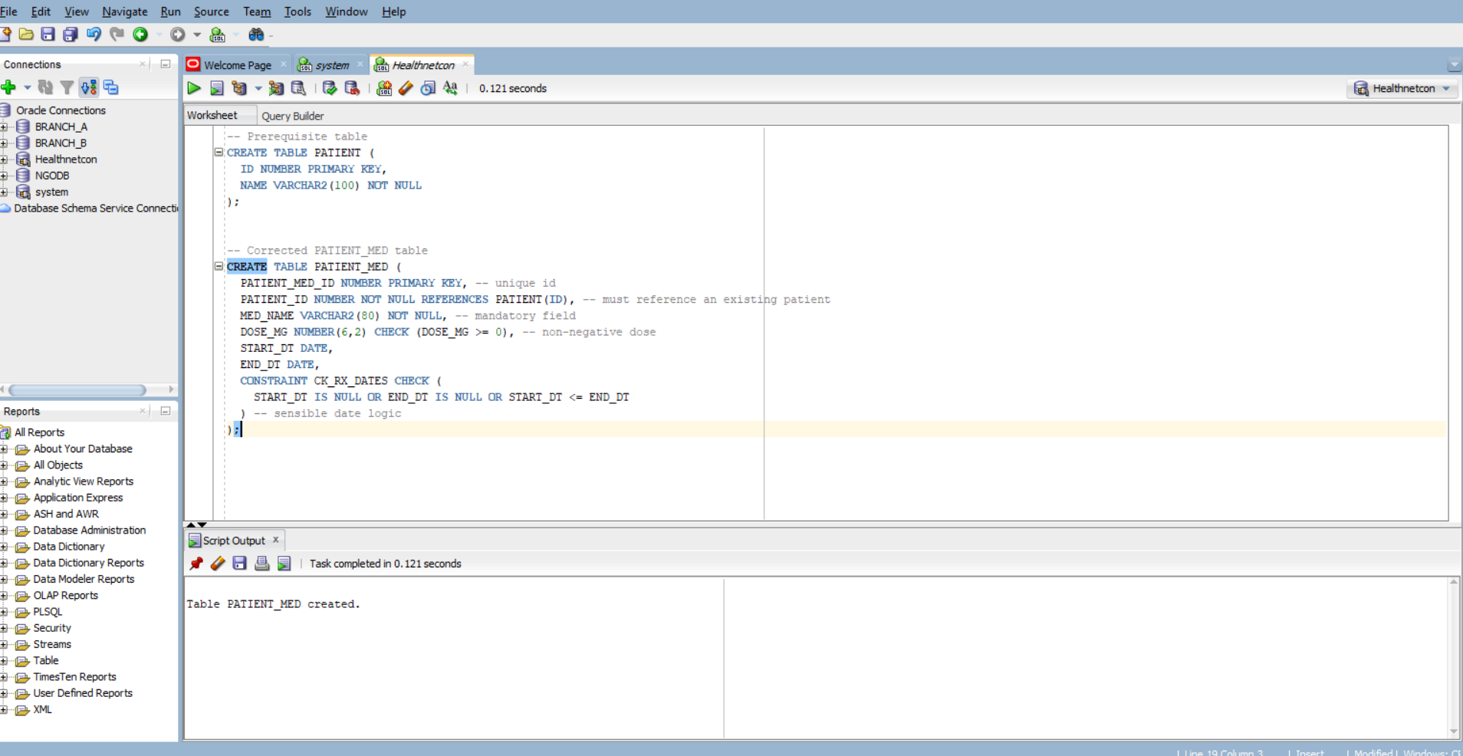

-- 1. Negative dose violates CHECK constraint

INSERT INTO PATIENT_MED VALUES (1, 1, 'Amoxicillin', -50, TO_DATE('2025-10-01','YYYY-MM-DD'), TO_DATE('2025-10-10','YYYY-MM-DD'));

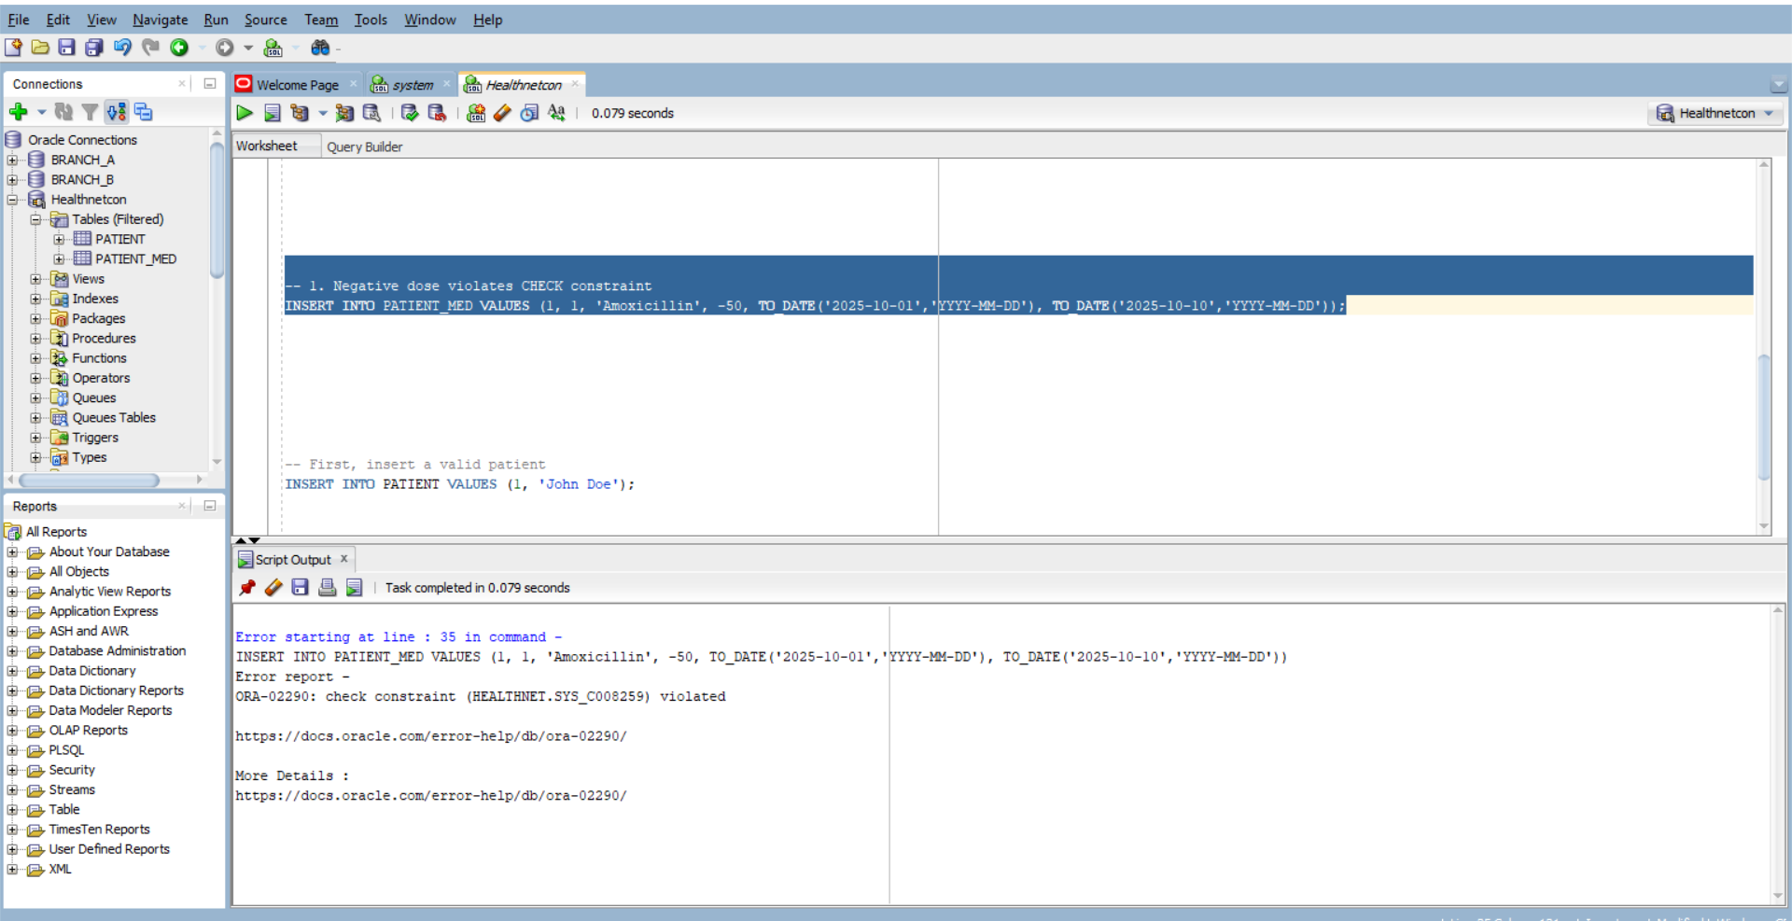

-- 2. Inverted dates violate CK_RX_DATES constraint

INSERT INTO PATIENT_MED VALUES (2, 1, 'Ibuprofen', 200, TO_DATE('2025-10-15','YYYY-MM-DD'), TO_DATE('2025-10-10','YYYY-MM-DD'));

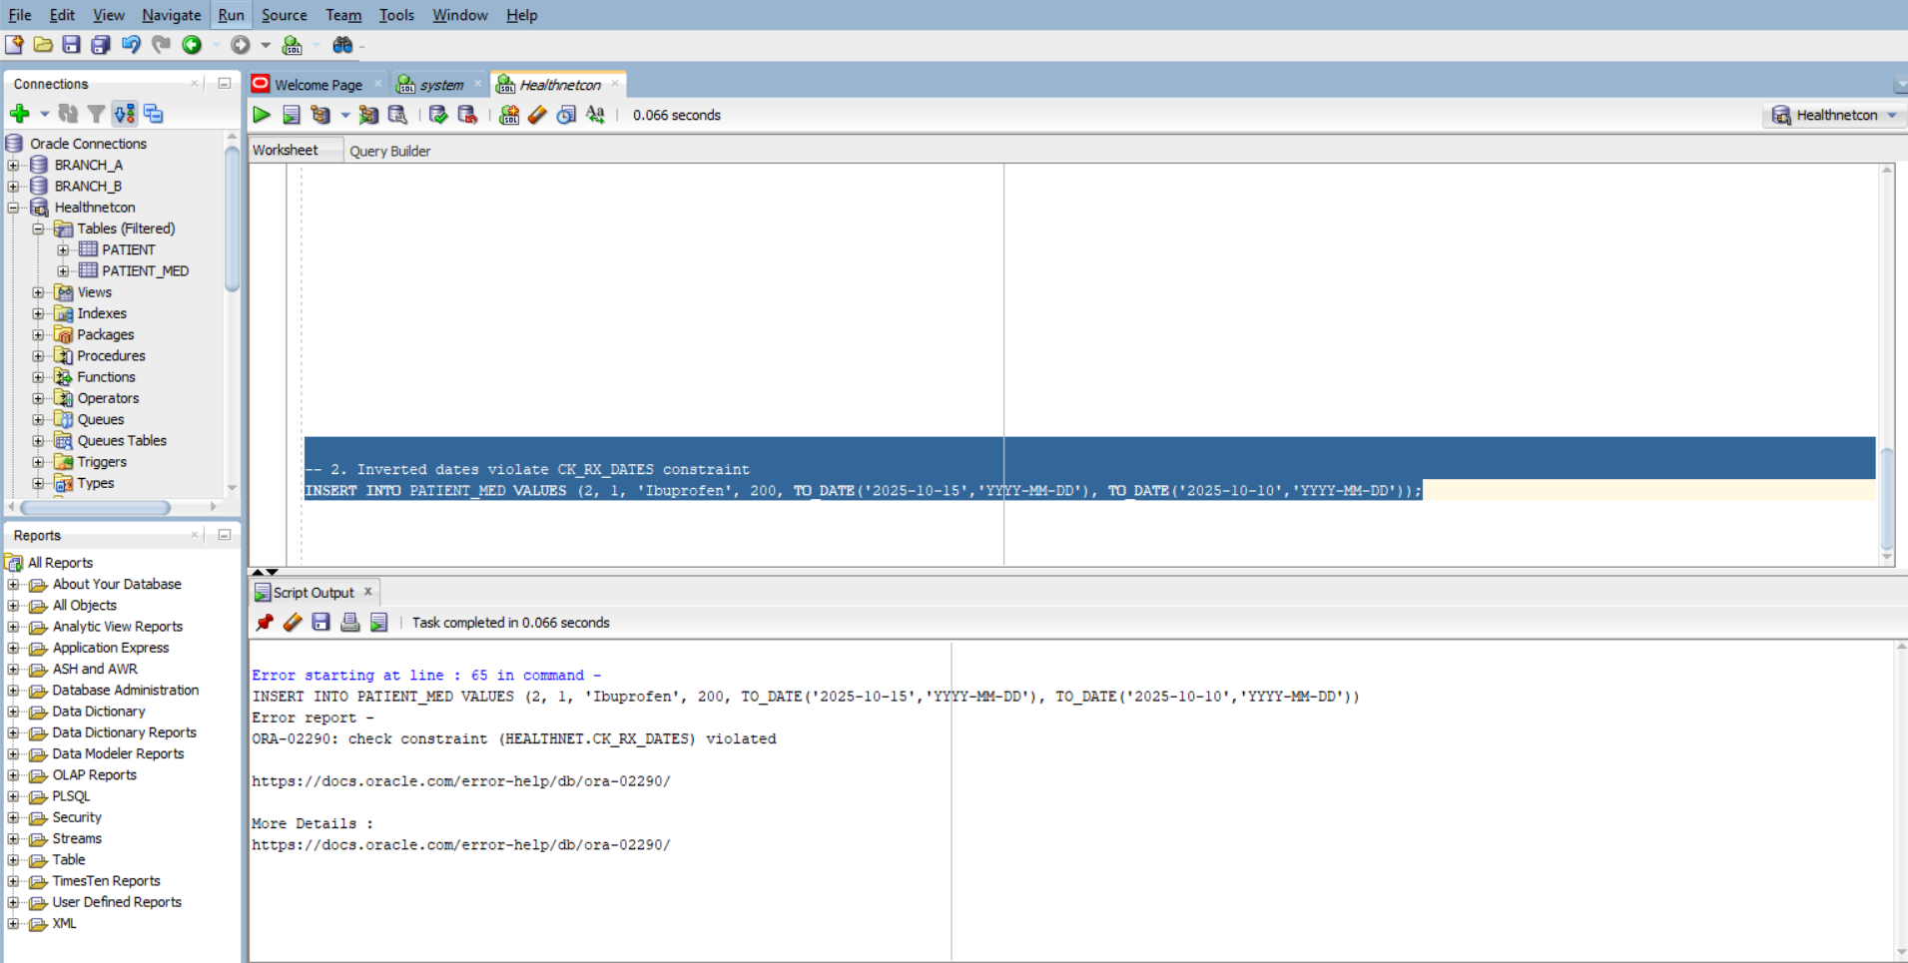

-- First, insert a valid patient

INSERT INTO PATIENT VALUES (1, 'John Doe');

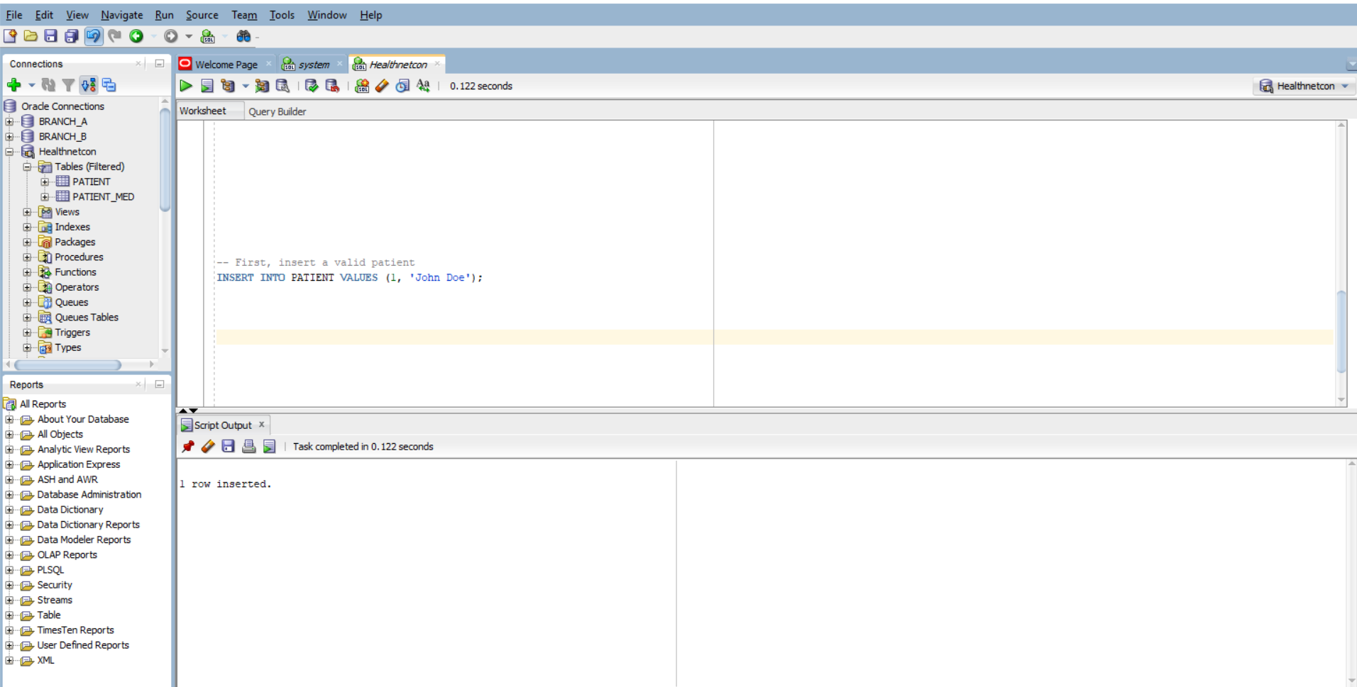

-- 1. Valid prescription

INSERT INTO PATIENT_MED VALUES (3, 1, 'Paracetamol', 500, TO_DATE('2025-10-01','YYYY-MM-DD'), TO_DATE('2025-10-05','YYYY-MM-DD'));

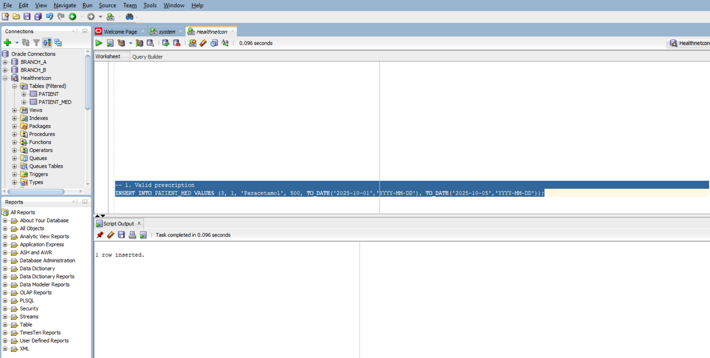

-- 2. Valid prescription with NULL dates

INSERT INTO PATIENT_MED VALUES (4, 1, 'Cetirizine', 10, NULL, NULL);

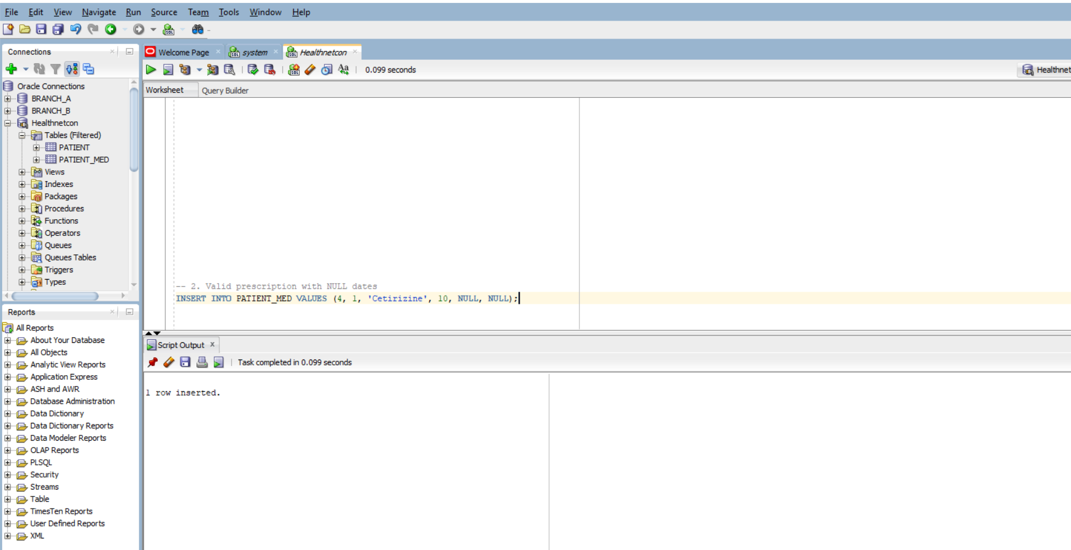

select * from patient_med;

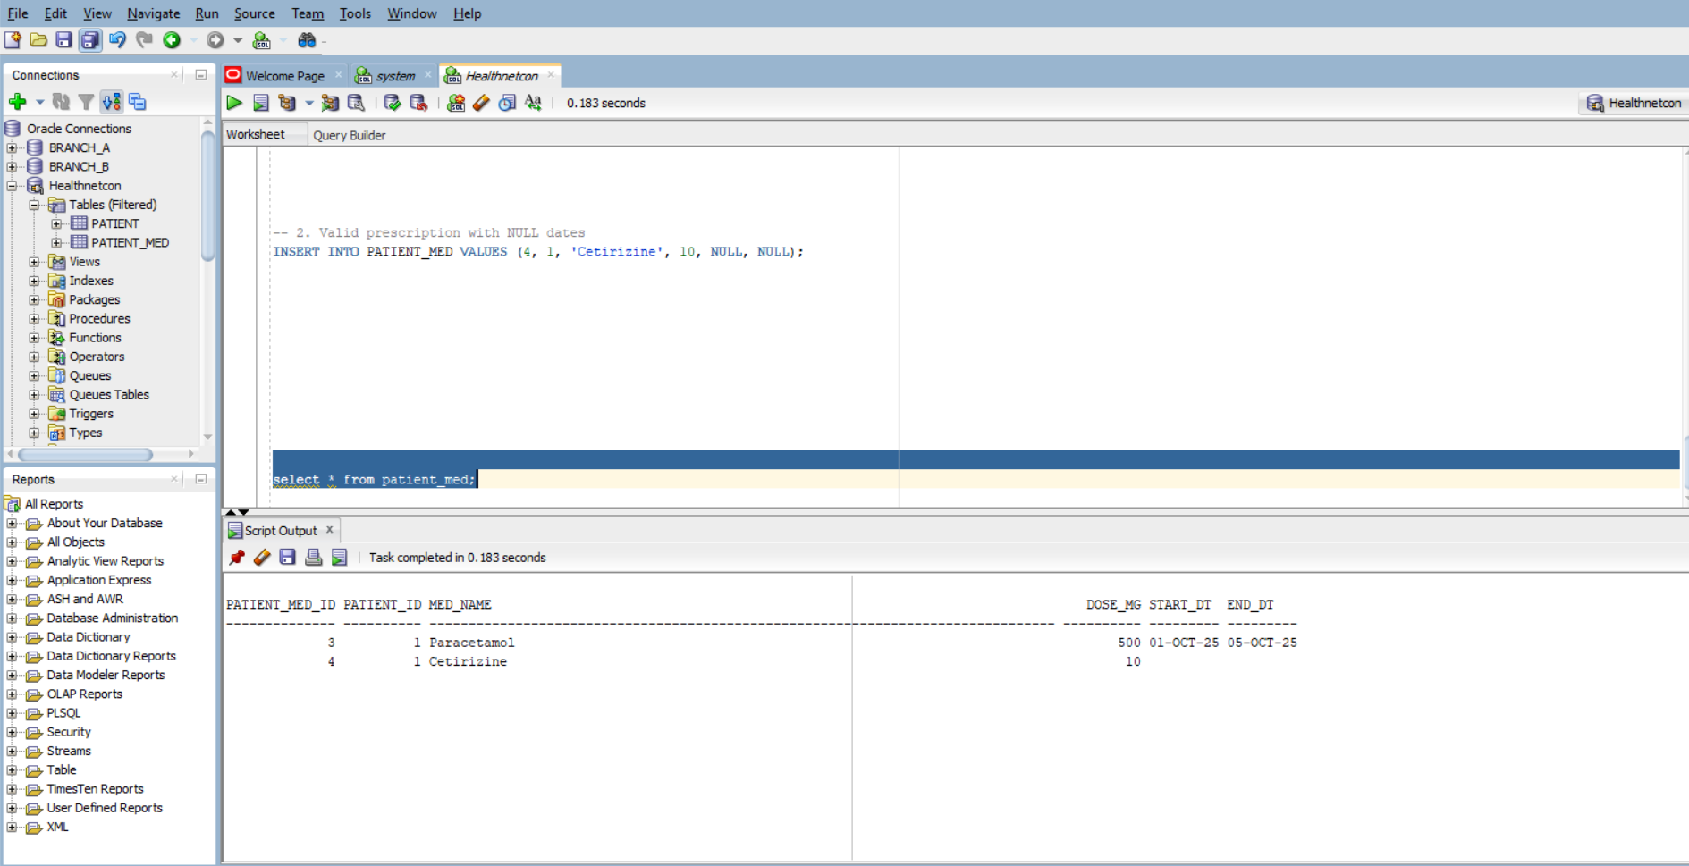

| **Error Type** | **Buggy Code** | **Correction** | **Explanation** |
| --- | --- | --- | --- |
| **Missing commas** | No commas between column definitions | Added commas between each column definition | SQL requires commas to separate columns in a CREATE TABLE statement |
| **Missing NOT NULL** | MED_NAME VARCHAR2(80) | MED_NAME VARCHAR2(80) NOT NULL | Ensures MED_NAME is mandatory |
| **Malformed CHECK clause** | DOSE_MG NUMBER(6,2) CHECK DOSE_MG >= 0 | DOSE_MG NUMBER(6,2) CHECK (DOSE_MG >= 0) | CHECK constraints must be enclosed in parentheses |
| **Invalid date logic** | CHECK (START_DT <= END_DT WHEN BOTH NOT NULL) | CHECK (START_DT IS NULL OR END_DT IS NULL OR START_DT <= END_DT) | SQL doesn't support "WHEN BOTH NOT NULL"; use logical OR to allow NULLs |
| **Missing NOT NULL on FK** | PATIENT_ID NUMBER REFERENCES PATIENT(ID) | PATIENT_ID NUMBER NOT NULL REFERENCES PATIENT(ID) | Ensures foreign key is mandatory |
| **2. -- Main bill table**  **CREATE TABLE BILL (**  **ID NUMBER PRIMARY KEY,**  **TOTAL NUMBER(12,2)**  **);**  **-- Items linked to bills**  **CREATE TABLE BILL_ITEM (**  **BILL_ID NUMBER,**  **AMOUNT NUMBER(12,2),**  **UPDATED_AT DATE,**  **CONSTRAINT FK_BILL_ITEM_BILL FOREIGN KEY (BILL_ID) REFERENCES BILL(ID)**  **);**  **-- Audit log for changes**  **CREATE TABLE BILL_AUDIT (**  **BILL_ID NUMBER,**  **OLD_TOTAL NUMBER(12,2),**  **NEW_TOTAL NUMBER(12,2),**  **CHANGED_AT DATE**  **);** |  |  |  |

Correct Compound Trigger: TRG_BILL_TOTAL_CMP: it updates BILL.TOTAL once per statement and logs changes into BILL_AUDIT, avoiding mutating-table errors and redundant updates.

CREATE OR REPLACE TRIGGER TRG_BILL_TOTAL_STMT

AFTER INSERT OR UPDATE OR DELETE ON BILL_ITEM

DECLARE

TYPE bill_id_table IS TABLE OF BILL_ITEM.BILL_ID%TYPE INDEX BY PLS_INTEGER;

v_bill_ids bill_id_table;

v_index PLS_INTEGER := 0;

BEGIN

-- Collect affected BILL_IDs

FOR r IN (

SELECT DISTINCT BILL_ID FROM BILL_ITEM

WHERE BILL_ID IS NOT NULL

) LOOP

v_index := v_index + 1;

v_bill_ids(v_index) := r.BILL_ID;

END LOOP;

-- Recompute totals and insert audit rows

FOR i IN 1 .. v_index LOOP

DECLARE

v_old_total BILL.TOTAL%TYPE;

v_new_total BILL.TOTAL%TYPE;

BEGIN

SELECT TOTAL INTO v_old_total FROM BILL WHERE ID = v_bill_ids(i);

SELECT NVL(SUM(AMOUNT), 0) INTO v_new_total FROM BILL_ITEM WHERE BILL_ID = v_bill_ids(i);

UPDATE BILL SET TOTAL = v_new_total WHERE ID = v_bill_ids(i);

INSERT INTO BILL_AUDIT (BILL_ID, OLD_TOTAL, NEW_TOTAL, CHANGED_AT)

VALUES (v_bill_ids(i), v_old_total, v_new_total, SYSDATE);

END;

END LOOP;

END;

/

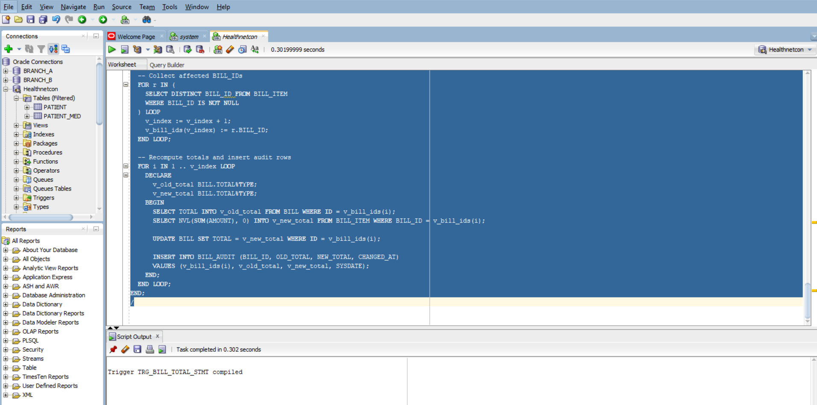

-- Insert bill items (trigger fires here)

INSERT INTO BILL_ITEM VALUES (1, 100, SYSDATE);

INSERT INTO BILL_ITEM VALUES (1, 200, SYSDATE);

INSERT INTO BILL_ITEM VALUES (2, 300, SYSDATE);

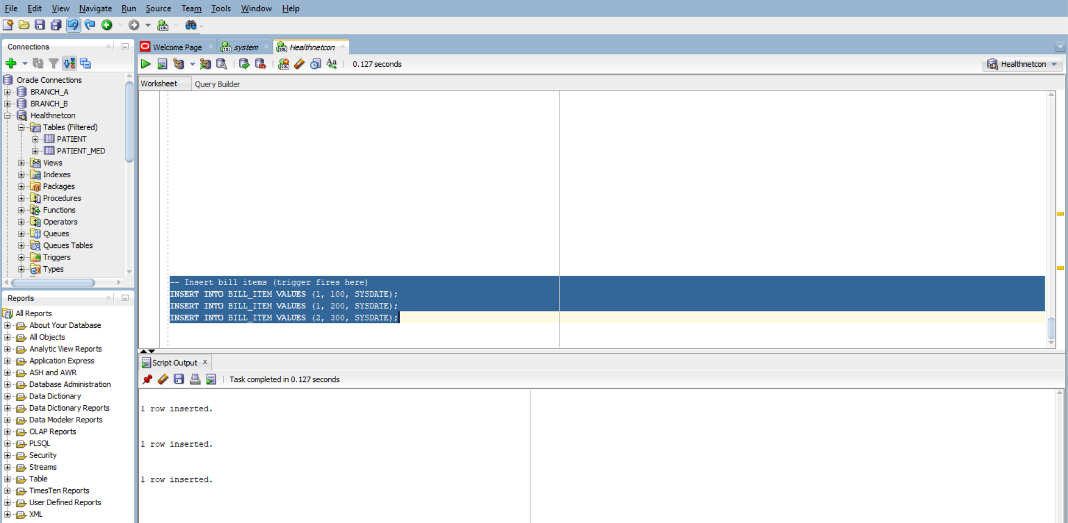

-- Update an item (trigger fires)

UPDATE BILL_ITEM SET AMOUNT = 150 WHERE BILL_ID = 1 AND AMOUNT = 100;

-- Delete an item (trigger fires)

DELETE FROM BILL_ITEM WHERE BILL_ID = 2 AND AMOUNT = 300;

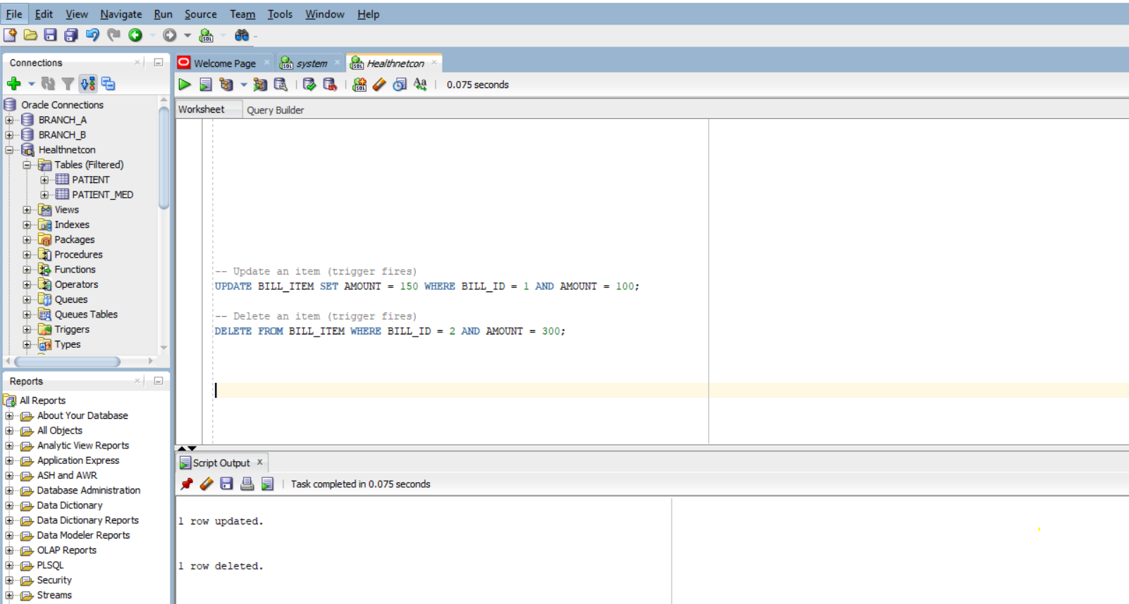

-- Check updated totals

SELECT * FROM BILL;

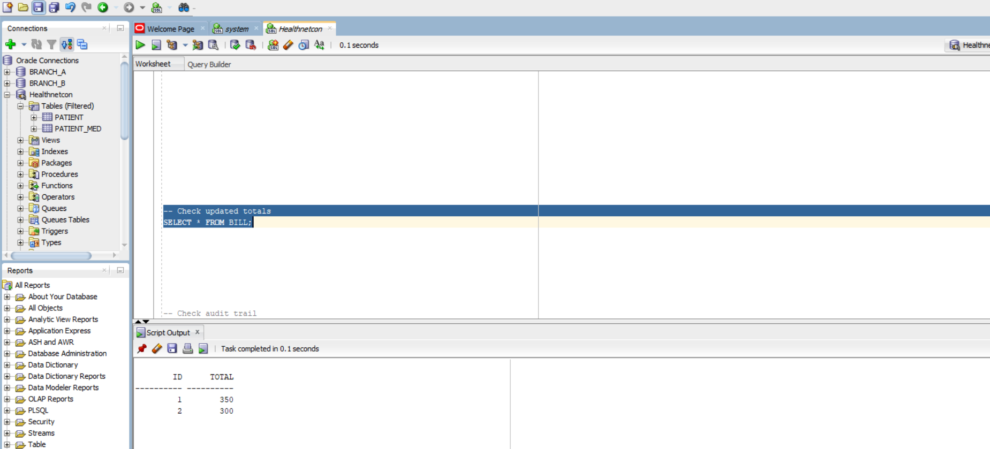

-- Check audit trail

SELECT * FROM BILL_AUDIT ORDER BY CHANGED_AT;

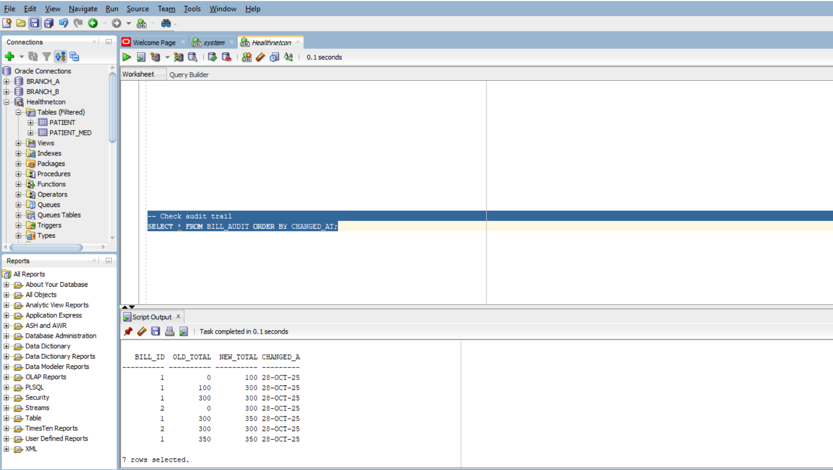

* BILL.TOTAL for ID 1 should reflect the sum of its items (e.g., 150 + 200 = 350).
* BILL.TOTAL for ID 2 should be 0 after deletion.
* BILL_AUDIT should show old and new totals for each change.

3.

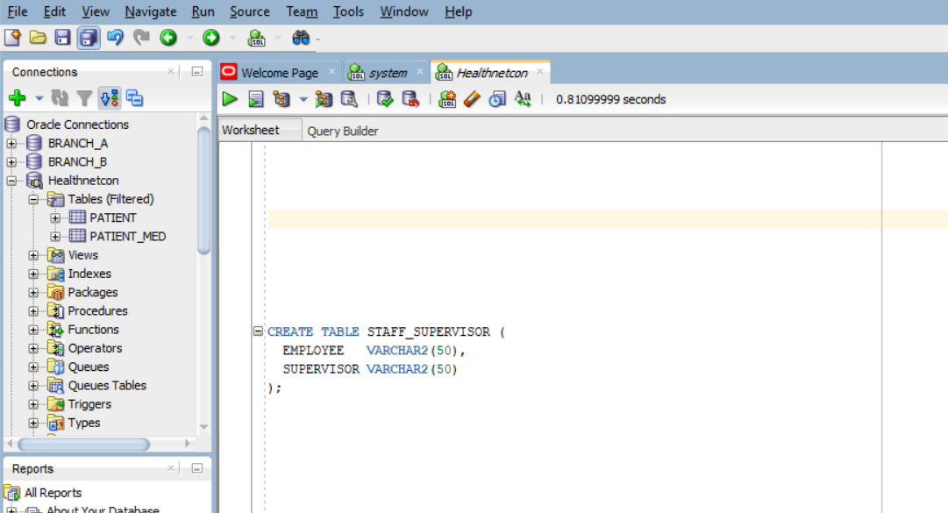

Inserting rows

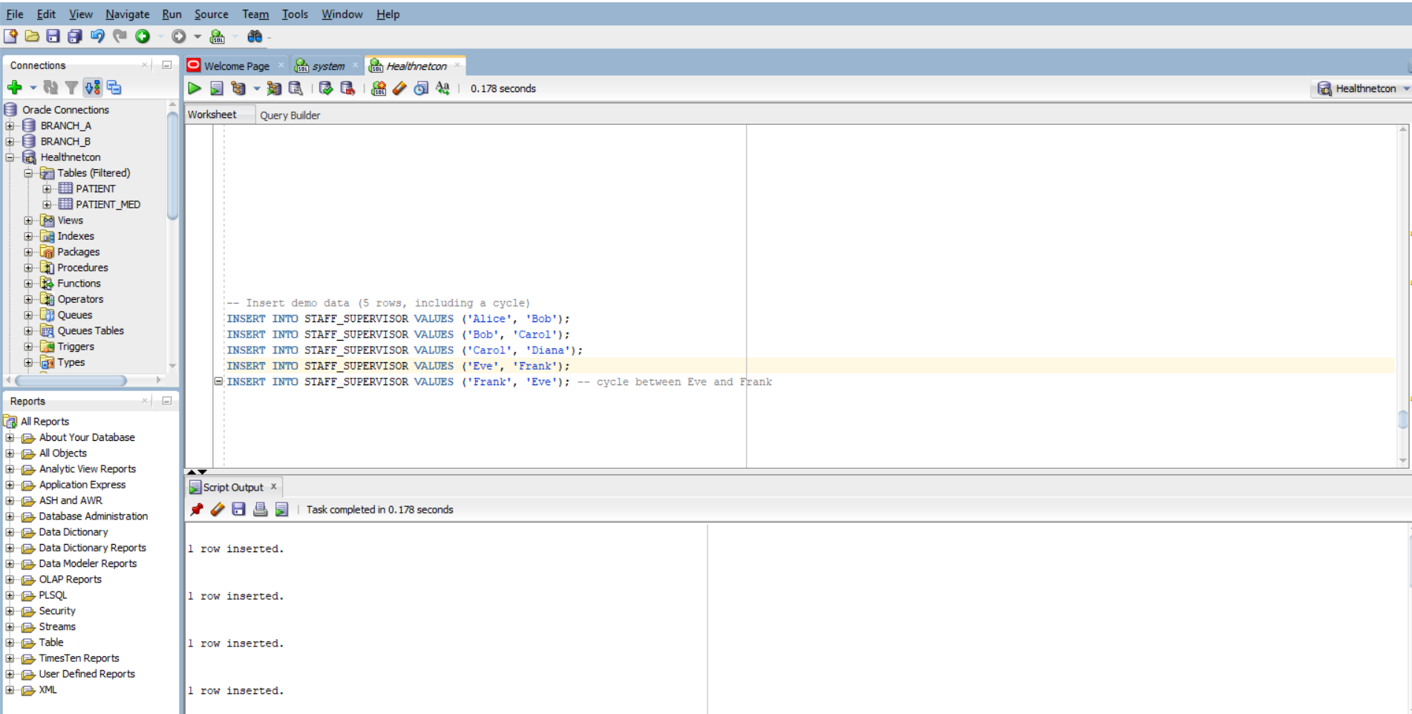

-- Corrected recursive query

WITH SUPERS (EMP, SUP, HOPS, PATH) AS (

-- Anchor: start with direct supervision, hop count = 1

SELECT EMPLOYEE, SUPERVISOR, 1, EMPLOYEE || '>' || SUPERVISOR

FROM STAFF_SUPERVISOR

UNION ALL

-- Recursive: climb up the supervision chain

SELECT S.EMPLOYEE, T.SUP, T.HOPS + 1, T.PATH || '>' || T.SUP

FROM STAFF_SUPERVISOR S

JOIN SUPERS T ON S.SUPERVISOR = T.EMP

WHERE INSTR(T.PATH, T.SUP) = 0 -- cycle guard

)

-- Final selection: top supervisor per employee

SELECT EMP, SUP AS TOP_SUPERVISOR, HOPS

FROM (

SELECT EMP, SUP, HOPS,

RANK() OVER (PARTITION BY EMP ORDER BY HOPS DESC) AS RANK

FROM SUPERS

)

WHERE RANK = 1;

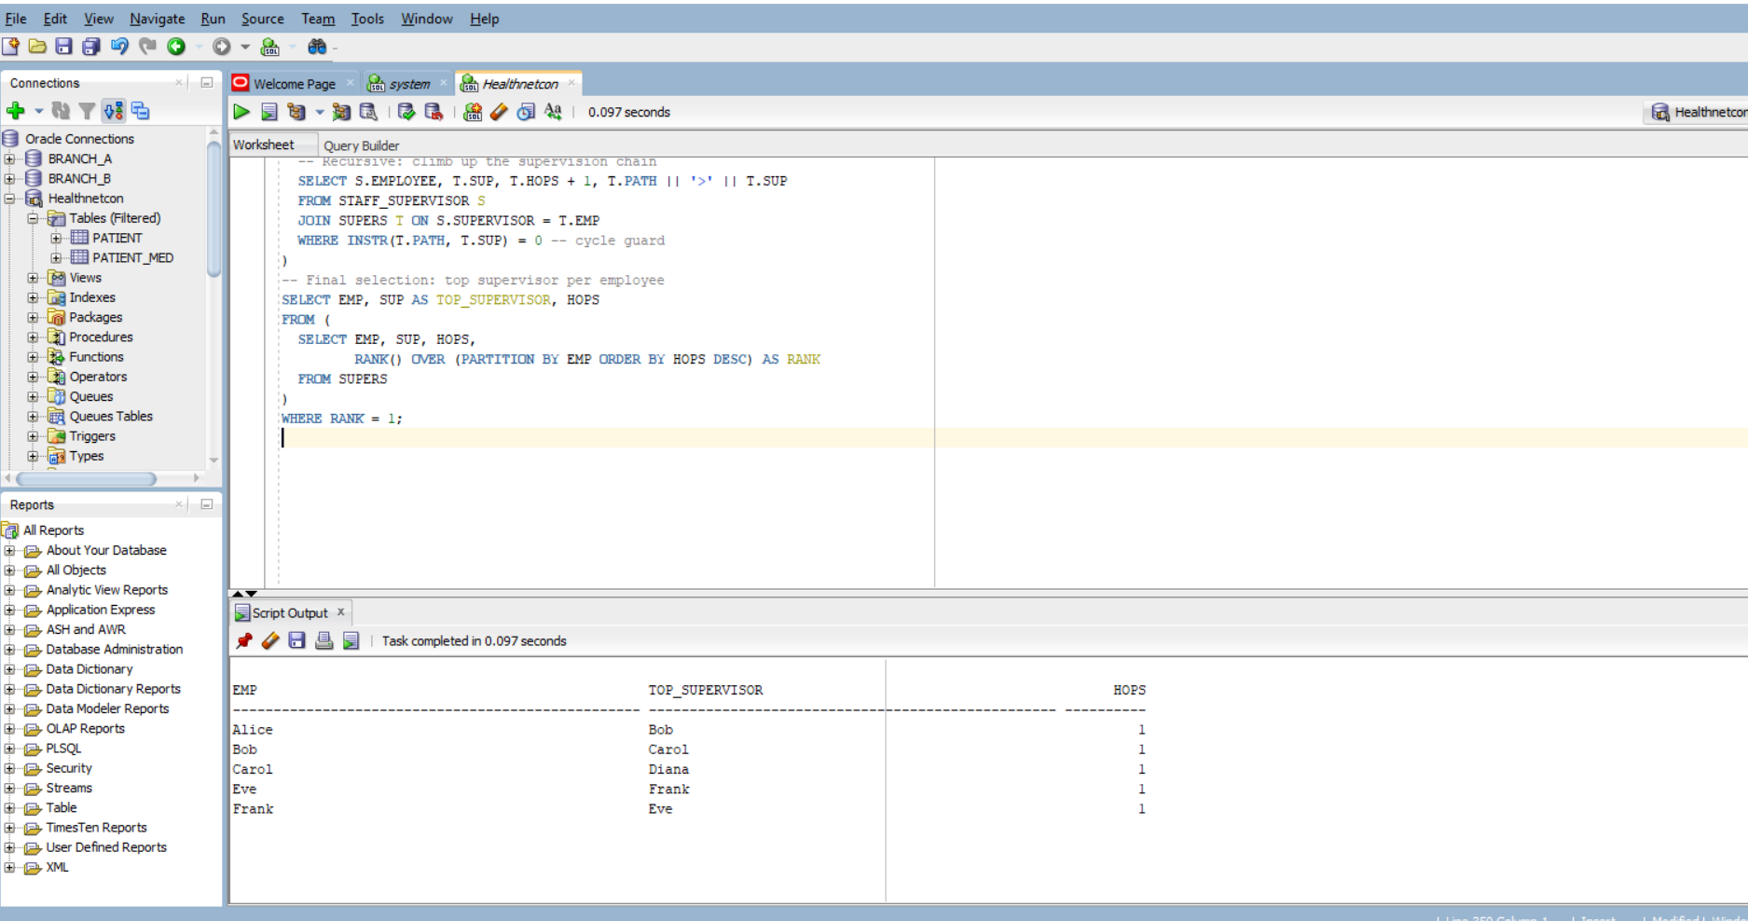

| **Bug** | **Fix** |
| --- | --- |
| Anchor hop count was 0 | Set to 1 to reflect first supervision step |
| Join direction was reversed | Corrected to climb up: S.SUPERVISOR = T.EMP |
| Cycle guard was naive | Improved with INSTR(PATH, T.SUP) = 0 |
| Scalar subquery with MAX(HOPS or the **number of steps** it takes to reach an employee’s **top supervisor** by following the chain of supervision) | Replaced with RANK() analytic function for clarity and correctness |

Diana

└── Carol

└── Bob

└── Alice

Eve ↔ Frank (cycle)

4.

CREATE TABLE TRIPLE (

S VARCHAR2(100),

P VARCHAR2(50),

O VARCHAR2(100)

);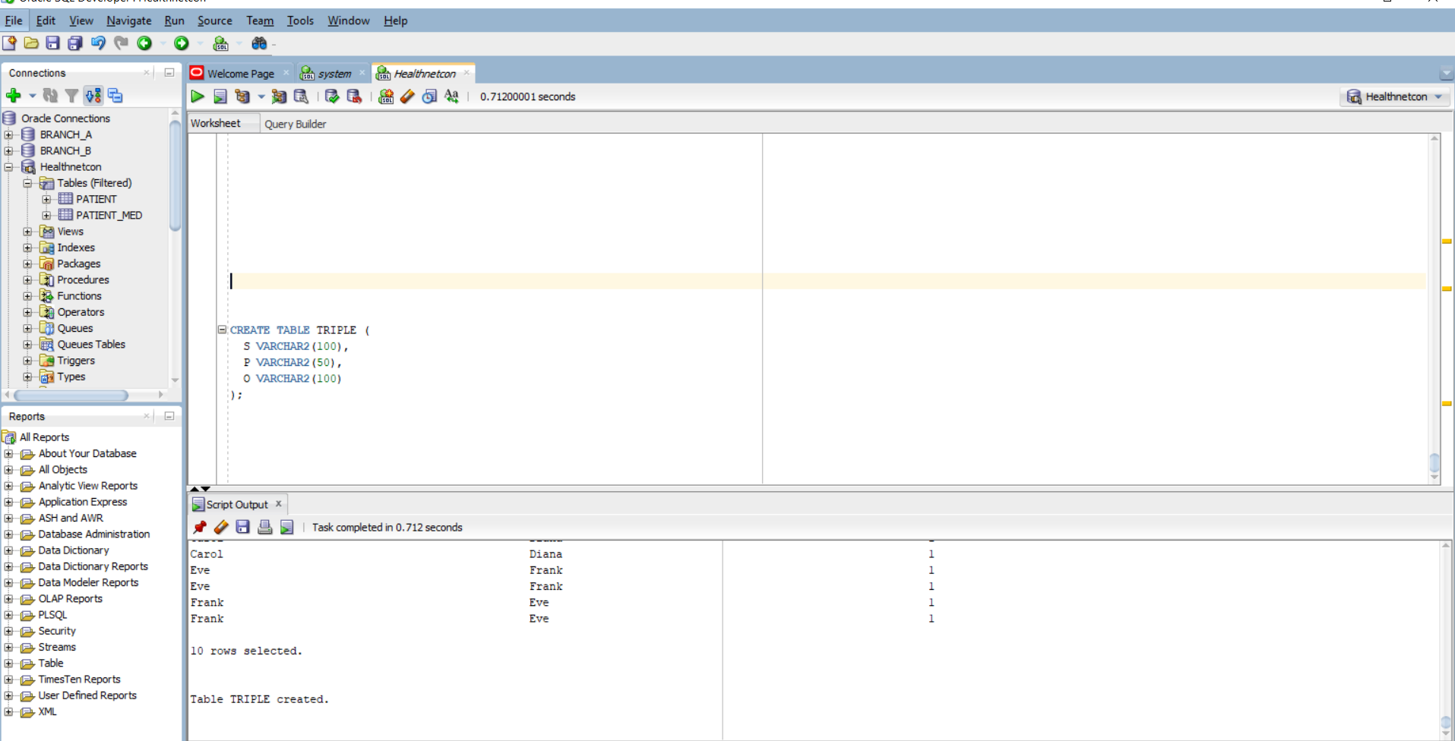

-- Patient diagnoses

INSERT INTO TRIPLE VALUES ('patient1', 'hasDiagnosis', 'Influenza');

INSERT INTO TRIPLE VALUES ('patient2', 'hasDiagnosis', 'COVID19');

INSERT INTO TRIPLE VALUES ('patient3', 'hasDiagnosis', 'Malaria');

INSERT INTO TRIPLE VALUES ('patient4', 'hasDiagnosis', 'Diabetes');

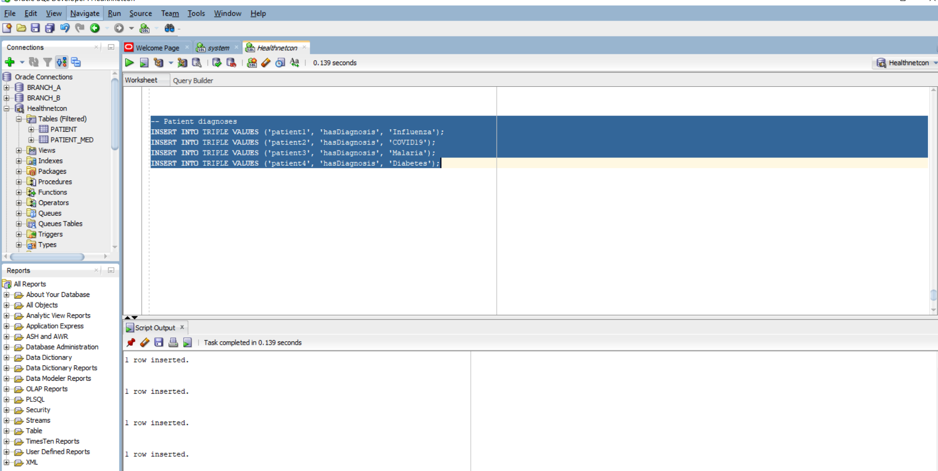

-- Taxonomy edges

INSERT INTO TRIPLE VALUES ('Influenza', 'isA', 'ViralInfection');

INSERT INTO TRIPLE VALUES ('COVID19', 'isA', 'ViralInfection');

INSERT INTO TRIPLE VALUES ('Malaria', 'isA', 'ParasiticInfection');

INSERT INTO TRIPLE VALUES ('ViralInfection', 'isA', 'InfectiousDisease');

INSERT INTO TRIPLE VALUES ('ParasiticInfection', 'isA', 'InfectiousDisease');

INSERT INTO TRIPLE VALUES ('Diabetes', 'isA', 'ChronicDisease');

Check inserted rows;

select * from triple;

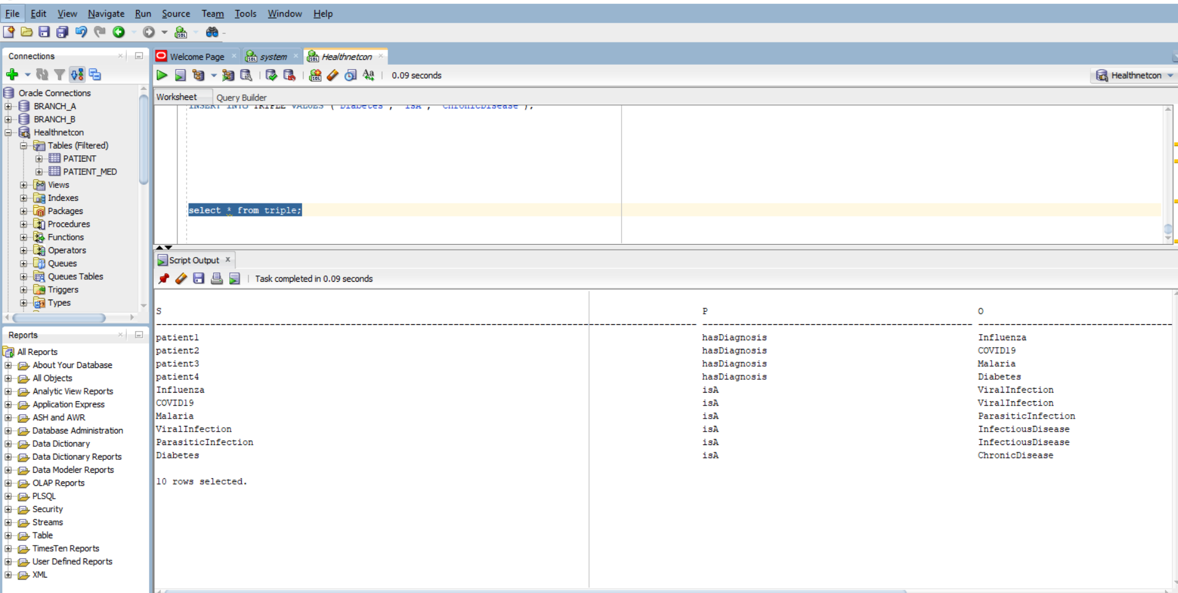

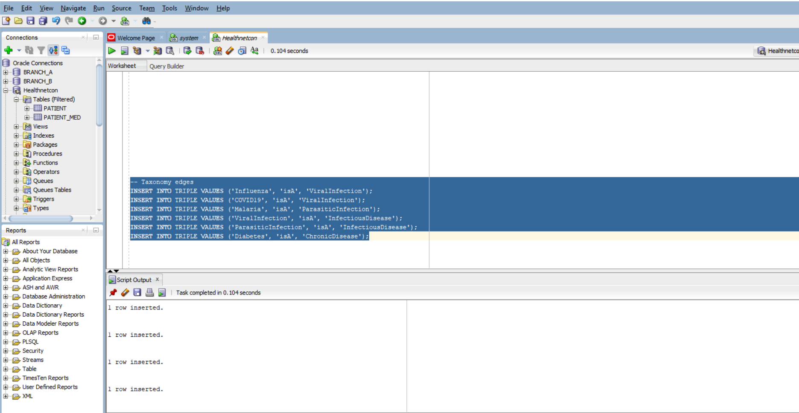

WITH ISA(ANCESTOR, CHILD) AS (

-- Anchor: direct isA relationships

SELECT O, S FROM TRIPLE WHERE P = 'isA'

UNION ALL

-- Recursive: climb up the taxonomy

SELECT I.ANCESTOR, T.S

FROM TRIPLE T

JOIN ISA I ON T.P = 'isA' AND T.O = I.CHILD

),

INFECTIOUS_PATIENTS AS (

SELECT DISTINCT T.S

FROM TRIPLE T

JOIN ISA ON T.O = ISA.CHILD

WHERE T.P = 'hasDiagnosis'

AND ISA.ANCESTOR = 'InfectiousDisease'

)

SELECT S AS PATIENT_ID FROM INFECTIOUS_PATIENTS;

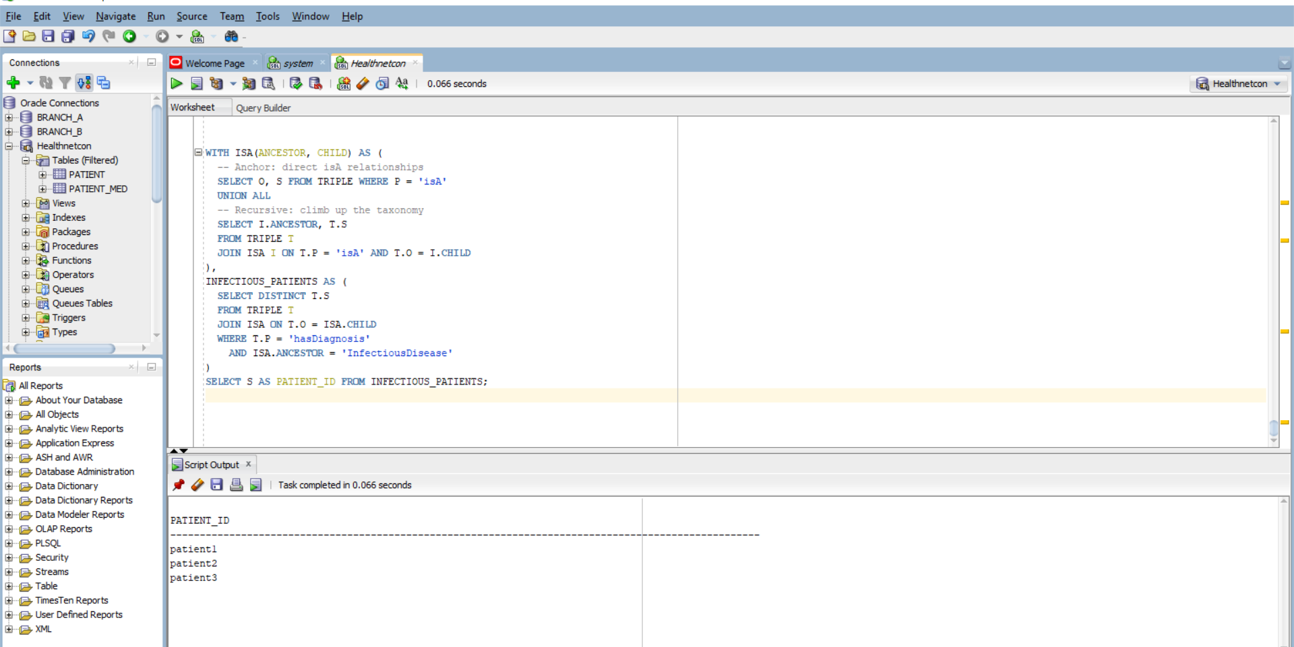

• Represent facts in a flexible, searchable format

• Link concepts together (like diseases to categories)

• Enable reasoning and inference (e.g., if Influenza is an InfectiousDisease, then patient1 has an InfectiousDisease)

5.

-- Create clinic table with spatial geometry

CREATE TABLE CLINIC (

ID NUMBER PRIMARY KEY,

NAME VARCHAR2(100),

GEOM SDO_GEOMETRY

);

INSERT INTO USER_SDO_GEOM_METADATA

(TABLE_NAME, COLUMN_NAME, DIMINFO, SRID)

VALUES (

'CLINIC',

'GEOM',

SDO_DIM_ARRAY(

SDO_DIM_ELEMENT('Longitude', 30.0, 31.0, 0.005),

SDO_DIM_ELEMENT('Latitude', -2.5, -1.5, 0.005)

),

4326

);

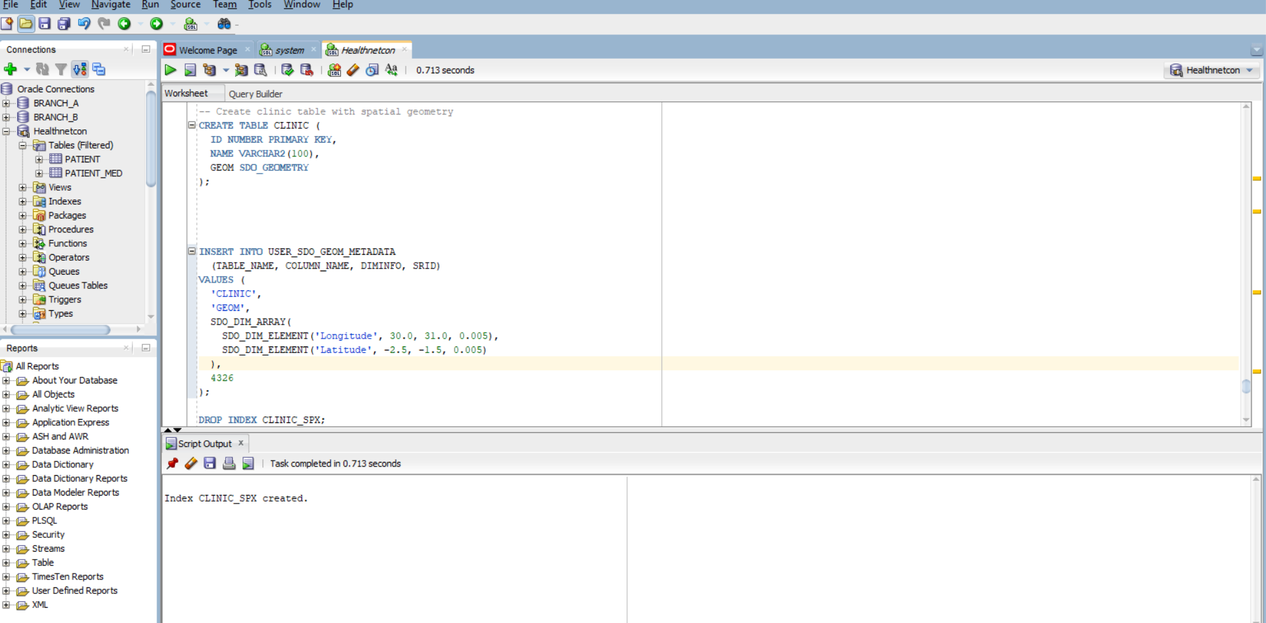

-- Create spatial index

CREATE INDEX CLINIC_SPX ON CLINIC(GEOM)

INDEXTYPE IS MDSYS.SPATIAL_INDEX;

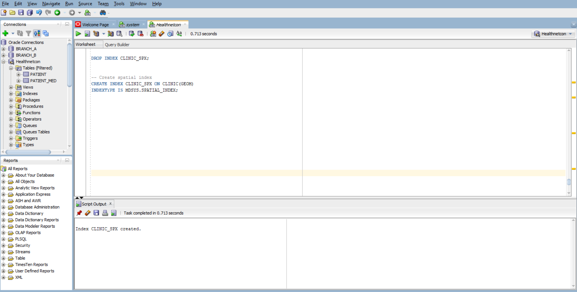

-- Ambulance is at (30.0600, -1.9570)

INSERT INTO CLINIC VALUES (

1, 'Kigali Central Clinic',

SDO_GEOMETRY(2001, 4326, SDO_POINT_TYPE(30.0610, -1.9575, NULL), NULL, NULL)

);

INSERT INTO CLINIC VALUES (

2, 'Nyamirambo Health Center',

SDO_GEOMETRY(2001, 4326, SDO_POINT_TYPE(30.0595, -1.9560, NULL), NULL, NULL)

);

INSERT INTO CLINIC VALUES (

3, 'Gikondo Medical',

SDO_GEOMETRY(2001, 4326, SDO_POINT_TYPE(30.0700, -1.9500, NULL), NULL, NULL)

);

COMMIT; 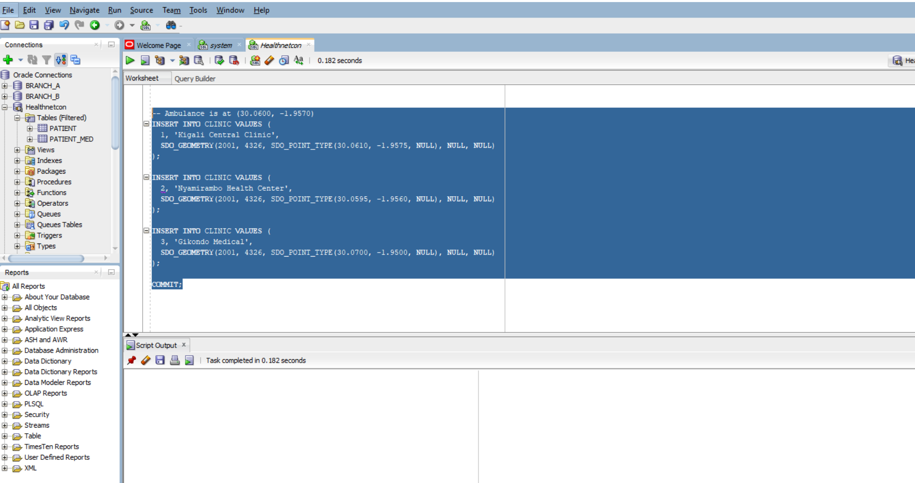

SELECT C.ID, C.NAME

FROM CLINIC C

WHERE SDO_WITHIN_DISTANCE(

C.GEOM,

SDO_GEOMETRY(2001, 4326, SDO_POINT_TYPE(30.0600, -1.9570, NULL), NULL, NULL),

'distance=1 unit=KM'

) = 'TRUE';

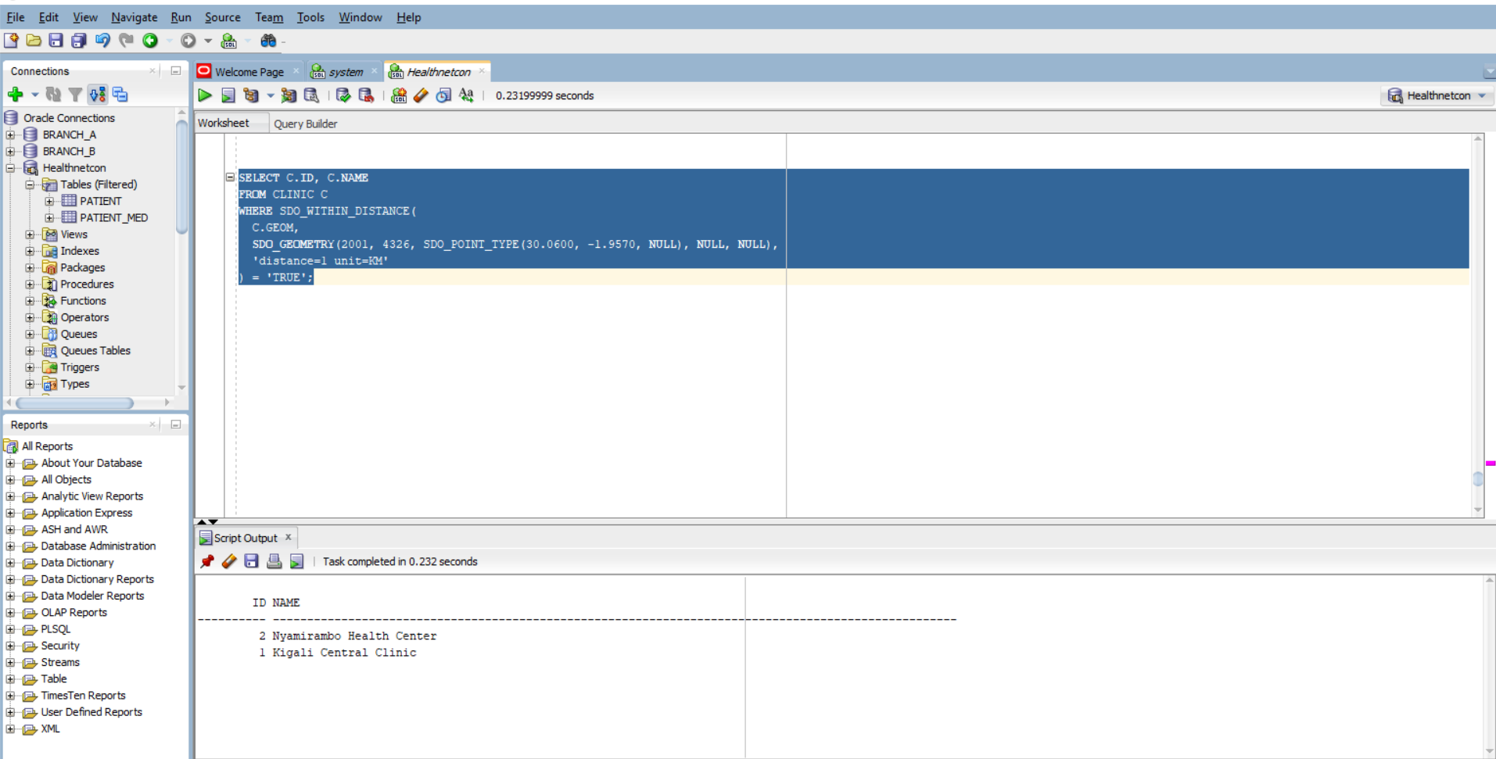

SELECT C.ID, C.NAME,

SDO_GEOM.SDO_DISTANCE(

C.GEOM,

SDO_GEOMETRY(2001, 4326, SDO_POINT_TYPE(30.0600, -1.9570, NULL), NULL, NULL),

0.005,

'unit=KM'

) AS KM

FROM CLINIC C

ORDER BY KM

FETCH FIRST 3 ROWS ONLY;

